Занятие 1. Концептуальные карты

Концептуальные карты — графическое представление знаний, состоящее из концептов и отношений между ними. Определим концепт как воспринимаемую закономерность в события или объектах, либо запись об этих событиях или объектах, обозначаемую меткой. Как правило, концепты представляют прямоугольниками, либо кругами, а отношения между ними — линиями, соединяющими их. Надпись над линией обозначает связь между концептами. Концепты обычно обозначают одним словом, либо словосочетанием. Кроме того, могут использоваться специальные символы, например, + или %. Тройки концепт-связь-концепт образуют высказывания, являющиеся значимым утверждением о некотором объекте, либо событии. Иногда их называют семантическими единицами или единицами значения (смысла).
Другой характеристикой концептуальных карт является то, что концепты представлены на иерархический манер: более общие указаны сверху, наиболее специализированные — внизу.
Ещё одной важной характеристикой концептуальной карты является понятие включения перекрёстных ссылок. Они позволяют связать концепты из различных областей концептуальной карты.
Последний аспект структуры концептуальной карты заключается в том, что она содержит конкретные примеры объектом или событий.

Таким образом, концептуальные карты определяются:
1. Теоретические основы: Теория обучения Аусубеля и конструктивистская эпистемология.
2. Условно-иерархическая структура.
3. Использование значимых и не ограниченных имён связей.
4. Способ определения концептов.
Стандартный метод построения концептуальной карты: Novak & Gowin (1984).

- Определяем тему или основной вопрос. Концептуальная карта, отвечающая более, чем на один вопрос, сложна для понимания и обработки.
- Второй шаг — определение списка наиболее важных концептов, связанных с выбранной темой.
- Далее выбранные концепты сортируются от более общих к более специфичным. Таким образом выстраивается иерархия отношений (морфология).
- Добавляются связи между концептами предметной области.
- Связи подписываются для образования семантических единиц. В результате получаем предварительную концептуальную карту.
- Строятся перекрёстные связи между концептами.
- Производится «ревью» всей модели и производятся необходимые правки.

Разработка концептуальной карты может вестись коллективом разработчиков.

Помимо концептуальных карт существую и другие технологии:

Knowledge Maps
Semantic Networks
Cognitive Maps
Mind Maps

Задание:
Разработать концептуальную карту области знаний «Научное исследование»
Занятие 2. Модель RDF

RDF – Resource Description Framework, модель (не формат!) описания ресурсов тройками: «субъект — предикат — объект». Использует для создания метаописаний, определения семантики понятий в понятном и для человека, и для машины виде. Каждый из элементов тройки задаётся с использование URI. В технологии Semantic Web данная тройка, как правило, имеет другой вид: «объект — атрибут — значение». Актуальная версия 1.1 от 25.02.2014 (https://www.w3.org/TR/rdf-syntax-grammar/)

TBox (terminological data) – описание предметной области классами, их свойствами и отношениями между ними.
ABox (assertion data) – описание предметной области конкретными её представителями и связями между ними.

RDF не делает различий между двумя этими моделями. Всё зависит от используемых соглашений.

Пример TBox
foaf:Person
a owl:Class;
rdfs:subClassOf owl:Thing;
rdfs:label "Person"@en.
ex:preferredName
a owl:DatatypeProperty;
rdfs:subPropertyOf skos:prefLabel, foaf:name, rdfs:label ;
rdfs:domain foaf:Person ;
rdfs:label "preferred name"@en .

Пример Abox
<#tobyink>
a foaf:Person ;
ex:preferredName "Toby Inkster" .

Ещё пример: INSERT – Abox data, CREATE TABLE – Tbox data.
Данные модели не могут быть преобразованы одна в другую.

Форматы представления

RDF – граф. Может описываться разными способами. Самые распространённые — триплеты и XML/RDF. Граф можно визуализировать с использованием таблиц стилей и XSLT. Так же используется формат RDF/JSON – JavaScript object notation.

RDF может использоваться для семантической разметки web-страниц. Для этого используется RDFa – RDF in Attributes – запись семантических данных внутри html атрибутов. Основные атрибуты, используемые для семантической разметки:
- about – a URI or CURIE specifying the resource the metadata is about
- rel and rev – specifying a relationship and reverse-relationship with another resource, respectively
- src, href and resource – specifying the partner resource
- property – specifying a property for the content of an element or the partner resource
- content – optional attribute that overrides the content of the element when using the property attribute
- datatype – optional attribute that specifies the datatype of text specified for use with the property attribute
- typeof – optional attribute that specifies the RDF type(s) of the subject or the partner resource (the resource that the metadata is about).
<div xmlns:dc="http://purl.org/dc/elements/1.1/"
about="http://www.example.com/books/wikinomics">
<span property="dc:title">Wikinomics</span>
<span property="dc:creator">Don Tapscott</span>
<span property="dc:date">2006-10-01</span>
</div>

N-Triples, Turtle, N3 – Сокращённая форма записи для RDF

@prefix rdf: <http://www.w3.org/1999/02/22-rdf-syntax-ns#> .
@prefix dc: <http://purl.org/dc/elements/1.1/> .
@prefix ex: <http://example.org/stuff/1.0/> .
<http://www.w3.org/TR/rdf-syntax-grammar>
dc:title "RDF/XML Syntax Specification (Revised)" ;
ex:editor [
ex:fullname "Dave Beckett";
ex:homePage <http://purl.org/net/dajobe/>
]

Запись в формате RDF/XML

<rdf:RDF xmlns:rdf="http://www.w3.org/1999/02/22-rdf-syntax-ns#" xmlns:ns="http://www.example.org/#">
<ns:Person rdf:about="http://www.example.org/#john">
<ns:hasMother rdf:resource="http://www.example.org/#susan" />
<ns:hasFather>
<rdf:Description rdf:about="http://www.example.org/#richard">
<ns:hasBrother rdf:resource="http://www.example.org/#luke" />
</rdf:Description>
</ns:hasFather>
</ns:Person>
</rdf:RDF>

Запросы к RDF: SPARQL

Примеры использования
RDFS (набор RDF описаний, определяющих онтологию)
Пример DC.
Пример FOAF.
Пример OWL.

Подробный классификатор-онтология семантики, распространённая сейчас:
http://schema.org/docs/full.html

Ещё одна популярная технология - микроформаты
Один из самых популярных микроформатов — hCard. Микроформат hCard универсален для описания людей и организаций, содержит базовую информацию и о том и о другом. Используя hcard можно указать такие свойства, как:
- n — имя;
- bday — дата рождения;
- geo — географическое расположение;
- tz — часовой пояс;
- uid — ссылка на идентичную сущность;
- photo — изображение;
- adr — адрес;
- org — название организации.
The Dublin Core Metadata Element Set is a vocabulary of fifteen properties for use in resource description. Dublin Core metadata is used to describe resources held, owned or produced by companies, governments and international organizations to supporting portal services or internal knowledge management. There are also implementations where Dublin Core metadata is used as a common exchange format supporting the aggregation of collections of metadata. The semantics of Dublin Core have been established by an international, cross-disciplinary group of professionals from librarianship, computer science, text encoding, the museum community, and other related fields of scholarship and practice. Although the Dublin Core was originally developed with an eye to describing document-like objects (because traditional text resources are fairly well understood), DC metadata can be applied to other resources as well. The Dublin Core element set has been kept as small and simple as possible to allow a non-specialist to create simple descriptive records for information resources easily and inexpensively, while providing for effective retrieval of those resources in the networked environment.
Term Name: contributor
Definition: | An entity responsible for making contributions to the resource.
Comment: | Examples of a Contributor include a person, an organization, or a service. Typically, the name of a Contributor should be used to indicate the entity.
Term Name: coverage
Definition: | The spatial or temporal topic of the resource, the spatial applicability of the resource, or the jurisdiction under which the resource is relevant.
Comment: | Spatial topic and spatial applicability may be a named place or a location specified by its geographic coordinates. Temporal topic may be a named period, date, or date range. A jurisdiction may be a named administrative entity or a geographic place to which the resource applies. Recommended best practice is to use a controlled vocabulary such as the Thesaurus of Geographic Names [TGN]. Where appropriate, named places or time periods can be used in preference to numeric identifiers such as sets of coordinates or date ranges.
References: | [TGN] http://www.getty.edu/research/tools/vocabulary/tgn/index.html
Term Name: creator
Definition: | An entity primarily responsible for making the resource.
Comment: | Examples of a Creator include a person, an organization, or a service. Typically, the name of a Creator should be used to indicate the entity.
Term Name: date
Definition: | A point or period of time associated with an event in the lifecycle of the resource.
Comment: | Date may be used to express temporal information at any level of granularity. Recommended best practice is to use an encoding scheme, such as the W3CDTF profile of ISO 8601 [W3CDTF].
References: | [W3CDTF] http://www.w3.org/TR/NOTE-datetime
Term Name: description
Definition: | An account of the resource.
Comment: | Description may include but is not limited to: an abstract, a table of contents, a graphical representation, or a free-text account of the resource.
Term Name: format
Definition: | The file format, physical medium, or dimensions of the resource.
Comment: | Examples of dimensions include size and duration. Recommended best practice is to use a controlled vocabulary such as the list of Internet Media Types [MIME].
References: | [MIME] http://www.iana.org/assignments/media-types/
Term Name: identifier
Definition: | An unambiguous reference to the resource within a given context.
Comment: | Recommended best practice is to identify the resource by means of a string conforming to a formal identification system.
Term Name: language
Definition: | A language of the resource.
Comment: | Recommended best practice is to use a controlled vocabulary such as RFC 4646 [RFC4646].
References: | [RFC4646] http://www.ietf.org/rfc/rfc4646.txt
Term Name: publisher
Definition: | An entity responsible for making the resource available.
Comment: | Examples of a Publisher include a person, an organization, or a service. Typically, the name of a Publisher should be used to indicate the entity.
Term Name: relation
Definition: | A related resource.
Comment: | Recommended best practice is to identify the related resource by means of a string conforming to a formal identification system.
Term Name: rights
Definition: | Information about rights held in and over the resource.
Comment: | Typically, rights information includes a statement about various property rights associated with the resource, including intellectual property rights.
Term Name: source
Definition: | A related resource from which the described resource is derived.
Comment: | The described resource may be derived from the related resource in whole or in part. Recommended best practice is to identify the related resource by means of a string conforming to a formal identification system.
Term Name: subject
Definition: | The topic of the resource.
Comment: | Typically, the subject will be represented using keywords, key phrases, or classification codes. Recommended best practice is to use a controlled vocabulary.
Term Name: title
Definition: | A name given to the resource.
Comment: | Typically, a Title will be a name by which the resource is formally known.
Term Name: type
Definition: | The nature or genre of the resource.
Comment: | Recommended best practice is to use a controlled vocabulary such as the DCMI Type Vocabulary [DCMITYPE]. To describe the file format, physical medium, or dimensions of the resource, use the Format element.
References: | [DCMITYPE] http://dublincore.org/documents/dcmi-type-vocabulary/

Занятие 3. Базовые конструкции OWL

W3C Recommendation 11 December 2012
The OWL 2 Web Ontology Language, informally OWL 2, is an ontology language for the Semantic Web with formally defined meaning. OWL 2 ontologies provide classes, properties, individuals, and data values and are stored as Semantic Web documents. OWL 2 ontologies can be used along with information written in RDF, and OWL 2 ontologies themselves are primarily exchanged as RDF documents.
The W3C OWL 2 Web Ontology Language (OWL) is a Semantic Web language designed to represent rich and complex knowledge about things, groups of things, and relations between things. OWL is a computational logic-based language such that knowledge expressed in OWL can be reasoned with by computer programs either to verify the consistency of that knowledge or to make implicit knowledge explicit. OWL documents, known as ontologies, can be published in the World Wide Web and may refer to or be referred from other OWL ontologies.
There are various syntaxes available for OWL which serve various purposes. The Functional-Style syntax is designed to be easier for specification purposes and to provide a foundation for the implementation of OWL 2 tools such as APIs and reasoners. The RDF/XML syntax for OWL is just RDF/XML, with a particular translation for the OWL constructs. This is the only syntax that is mandatory to be supported by all OWL 2 tools. The Manchester syntax is an OWL syntax that is designed to be easier for non-logicians to read. The OWL XML syntax is an XML syntax for OWL defined by an XML schema. There are tools that can translate between the different syntaxes for OWL. In many syntactic forms, OWL language constructs are also represented by IRIs, and some declarations might be needed to use the abbreviated forms as in the examples.

What is OWL 2?
OWL 2 is a language for expressing ontologies. The term ontology has a complex history both in and out of computer science, but we use it to mean a certain kind of computational artifact – i.e., something akin to a program, an XML schema, or a web page – generally presented as a document. An ontology is a set of precise descriptive statements about some part of the world (usually referred to as the domain of interest or the subject matter of the ontology). Precise descriptions satisfy several purposes: most notably, they prevent misunderstandings in human communication and they ensure that software behaves in a uniform, predictable way and works well with other software.
In order to precisely describe a domain of interest, it is helpful to come up with a set of central terms – often called vocabulary – and fix their meaning. Besides a concise natural language definition, the meaning of a term can be characterized by stating how this term is interrelated to the other terms. A terminology, providing a vocabulary together with such interrelation information constitutes an essential part of a typical OWL 2 document. Besides this terminological knowledge, an ontology might also contain so called assertional knowledge that deals with concrete objects of the considered domain rather than general notions.
OWL 2 is not a programming language: OWL 2 is declarative, i.e. it describes a state of affairs in a logical way. Appropriate tools (so-called reasoners) can then be used to infer further information about that state of affairs. How these inferences are realized algorithmically is not part of the OWL document but depends on the specific implementations. Still, the correct answer to any such question is predetermined by the formal semantics (which comes in two versions: the Direct Semantics and the RDF-Based Semantics. Only implementations that comply with these semantics will be regarded as OWL 2 conformant. Through its declarative nature, the activity of creating OWL 2 documents is conceptually different from programming. Still, as in both cases complex formal documents are created, certain notions from software engineering can be transferred to ontology engineering, such as methodological and collaborative aspects, modularization, patterns, etc.
OWL 2 is not a schema language for syntax conformance. Unlike XML, OWL 2 does not provide elaborate means to prescribe how a document should be structured syntactically. In particular, there is no way to enforce that a certain piece of information (like the social security number of a person) has to be syntactically present. This should be kept in mind as OWL has some features that a user might misinterpret this way.
OWL 2 is not a database framework. Admittedly, OWL 2 documents store information and so do databases. Moreover a certain analogy between assertional information and database content as well as terminological information and database schemata can be drawn. However, usually there are crucial differences in the underlying assumptions (technically: the used semantics). If some fact is not present in a database, it is usually considered false (the so-called closed-world assumption) whereas in the case of an OWL 2 document it may simply be missing (but possibly true), following the open-world assumption. Moreover, database schemata often come with the prescriptive constraint semantics mentioned above. Still, technically, databases provide a viable backbone in many ontology-oriented systems.

Modeling Knowledge: Basic Notions
OWL 2 is a knowledge representation language, designed to formulate, exchange and reason with knowledge about a domain of interest. Some fundamental notions should first be explained to understand how knowledge is represented in OWL 2. These basic notions are:
- Axioms: the basic statements that an OWL ontology expresses
- Entities: elements used to refer to real-world objects
- Expressions: combinations of entities to form complex descriptions from basic ones
While OWL 2 aims to capture knowledge, the kind of “knowledge” that can be represented by OWL does of course not reflect all aspects of human knowledge. OWL can be considered as a powerful general-purpose modeling language for certain parts of human knowledge. The results of the modeling processes are called ontologies – a terminology that also helps to avoid confusion since the term “model” is often used in a rather different sense in knowledge representation.
Now, in order to formulate knowledge explicitly, it is useful to assume that it consists of elementary pieces that are often referred to as statements or propositions. Statements like “it is raining” or “every man is mortal” are typical examples for such basic propositions. Indeed, every OWL 2 ontology is essentially just a collection of such basic “pieces of knowledge.” Statements that are made in an ontology are called axioms in OWL 2, and the ontology asserts that its axioms are true. In general, OWL statements might be either true or false given a certain state of affairs. This distinguishes them from entities and expressions as described further below.
When humans think, they draw consequences from their knowledge. An important feature of OWL is that it captures this aspect of human intelligence for the forms of knowledge that it can represent. But what does it mean, generally speaking, that a statement is a consequence of other statements? Essentially it means that this statement is true whenever the other statements are. In OWL terms: we say, a set of statements A entails a statement a if in any state of affairs wherein all statements from A are true, also a is true. Moreover, a set of statements may be consistent (that is, there is a possible state of affairs in which all the statements in the set are jointly true) or inconsistent (there is no such state of affairs). The formal semantics of OWL specifies, in essence, for which possible “states of affairs” a particular set of OWL statements is true.
There are OWL tools – reasoners – that can automatically compute consequences. The way ontological axioms interact can be very subtle and difficult for people to understand. This is both a strength and a weakness of OWL 2. It is a strength because OWL 2 tools can discover information that a person would not have spotted. This allows knowledge engineers to model more directly and the system to provide useful feedback and critique of the modeling. It is a weakness because it is comparatively difficult for humans to immediately foresee the actual effect of various constructs in various combinations. Tool support ameliorates the situation but successful knowledge engineering often still requires some amount of training and experience.
Having a closer look at statements in OWL, we see that they are rarely “monolithic” but more often have some internal structure that can be explicitly represented. They normally refer to objects of the world and describe them e.g. by putting them into categories (like “Mary is female”) or saying something about their relation (“John and Mary are married”). All atomic constituents of statements, be they objects (John, Mary), categories (female) or relations (married) are called entities. In OWL 2, we denote objects as individuals, categories as classes and relations as properties. Properties in OWL 2 are further subdivided. Object properties relate objects to objects (like a person to their spouse), while datatype properties assign data values to objects (like an age to a person). Annotation properties are used to encode information about (parts of) the ontology itself (like the author and creation date of an axiom) instead of the domain of interest.
As a central feature of OWL, names of entities can be combined into expressions using so called constructors. As a basic example, the atomic classes “female” and “professor” could be combined conjunctively to describe the class of female professors. The latter would be described by an OWL class expression, that could be used in statements or in other expressions. In this sense, expressions can be seen as new entities which are defined by their structure. In OWL, the constructors for each sort of entity vary greatly. The expression language for classes is very rich and sophisticated, whereas the expression language for properties is much less so. These differences have historical as well as technical reasons.

Classes, Properties, and Individuals – And Basic Modeling With Them
After these general considerations, we now engage in the details of modeling with OWL 2. In the subsequent sections, we introduce the essential modeling features that OWL 2 offers, provide examples and give some general comments on how to use them. We proceed from basic features, which are essentially available in any modeling language, to more advanced constructs.
Thereby we will represent information about a particular family. Note that we do not intend this example to be representative of the sorts of domains OWL should be used for, or as a canonical example of good modeling with OWL, or a correct representation of the rather complex, shifting, and culturally dependent domain of families. Instead, we intend it to be a rather simple exhibition of various features of OWL.

Classes and Instances
We start by introducing the persons we are talking about. This can be done as follows:
ClassAssertion( :Person :Mary )
This statement talks about an individual named Mary and states that this individual is a person. More technically, being a person is expressed by stating that Mary belongs to (or “is a member of” or, even more technically, “is an instance of”) the class of all persons. In general classes are used to group individuals that have something in common in order to refer to them. Hence, classes essentially represent sets of individuals. In modeling, classes are often used to denote the set of objects comprised by a concept of human thinking, like the concept person or the concept woman. Consequently, we can use the same type of statement to indicate that Mary is a woman by expressing that she is an instance of the class of women:
ClassAssertion( :Woman :Mary )
Hereby it also becomes clear that class membership is not exclusive: as there may be diverse criteria to group individuals (like gender, age, shoe size, etc.), one individual may well belong to several classes simultaneously.

Class Hierarchies
In the previous section, we were talking about two classes: the class of all persons and that of all women. To the human reader it is clear that these two classes are in a special relationship: Person is more general than Woman, meaning that whenever we know some individual to be a woman, that individual must be a person. However, this correspondence cannot be derived from the labels “Person” and “Woman” but is part of the human background knowledge about the world and our usage of those terms. Therefore, in order to enable a system to draw the desired conclusions, it has to be informed about this correspondence. In OWL 2, this is done by a so-called subclass axiom:
SubClassOf( :Woman :Person )
The presence of this axiom in an ontology enables reasoners to infer for every individual which is specified as an instance of the class Woman, that it is an instance of the class Person as well. As a rule of thumb, a subclass relationship between two classes A and B can be specified, if the phrase “every A is a B” makes sense and is correct.
It is common in ontological modeling to use subclass statements not only for sporadically declaring such interdependencies, but to model whole class hierarchies by specifying the generalization relationships of all classes in the domain of interest. Suppose we also want to state that all mothers are women:
SubClassOf( :Mother :Woman )
Then a reasoner could not only derive for every single individual that is classified as mother, that it is also a woman (and consequently a person), but also that Mother must be a subclass of Person – coinciding with our intuition. Technically, this means that the subclass relationship between classes is transitive. Besides this, it is also reflexive, meaning that every class is its own subclass – this is intuitive as well since clearly, every person is a person etc.
Classes in our vocabulary may effectively refer to the same sets, and OWL provides a mechanism by which they are considered to be semantically equivalent. For example, we use the term Person and Human interchangeably, meaning that every instance of the class Person is also an instance of class Human, and vice versa. Two classes are considered equivalent if they contain exactly the same individuals. The following example states that the class Person is equivalent to the class Human.
EquivalentClasses( :Person :Human )
Stating that Person and Human are equivalent amounts exactly to the same as stating that both Person is a subclass of Human and Human is a subclass of Person.

Class Disjointness
In Section 4.1, we stated that an individual can be an instance of several classes. However, in some cases membership in one class specifically excludes membership in another. For example, if we consider the classes Man and Woman, we know that no individual can be an instance of both classes (for the sake of the example, we disregard biological borderline cases). This “incompatibility relationship” between classes is referred to as (class) disjointness. Again, the information that two classes are disjoint is part of our background knowledge and has to be explicitly stated for a reasoning system to make use of it. This is done as follows:
DisjointClasses( :Woman :Man )
In practice, disjointness statements are often forgotten or neglected. The arguable reason for this could be that intuitively, classes are considered disjoint unless there is other evidence. By omitting disjointness statements, many potentially useful consequences can get lost. Note that in our example, the disjointness axiom is needed to deduce that Mary is not a man. Moreover, given the above axioms, a reasoner can infer the disjointness of the classes Mother and Man.

Object Properties
In the preceding sections we were concerned with describing single individuals, their class memberships, and how classes can relate to each other based on their instances. But more often than not, an ontology is also meant to specify how the individuals relate to other individuals. These relationships are central when describing a family. We start by indicating that Mary is John's wife.
ObjectPropertyAssertion( :hasWife :John :Mary )
Hereby, the entities describing in which way the individuals are related – like hasWife in our case, are called properties.
Note that the order in which the individuals are written is important. While “Mary is John's wife” might be true, “John is Mary's wife” certainly isn't. Indeed, this is a common source of modeling errors that can be avoided by using property names which allow only one unique intuitive reading. In case of nouns (like “wife”), such unambiguous names might be constructions with “of” or with “has” (wifeOf or hasWife). For verbs (like “to love”) an inflected form (loves) or a passive version with “by” (lovedBy) would prevent unintended readings.
We can also state that two individuals are not connected by a property. The following, for example, states that Mary is not Bill's wife.
NegativeObjectPropertyAssertion( :hasWife :Bill :Mary )
Negative property assertions provide a unique opportunity to make statements where we know something that is not true. This kind of information is particularly important in OWL where the default stance is that anything is possible until you say otherwise.

Property Hierarchies
In Section 4.2 we argued that it is useful to specify that one class membership implies another one. Essentially the same situation can occur for properties: whenever B is known to be A's wife, it is also known to be A's spouse (note, that this is not true the other way round). OWL allows to specify this statement as follows:
SubObjectPropertyOf( :hasWife :hasSpouse )
There is also a syntactic shortcut for property equivalence, which is similar to class equivalence.

Domain and Range Restrictions
Frequently, the information that two individuals are interconnected by a certain property allows to draw further conclusions about the individuals themselves. In particular, one might infer class memberships. For instance, the statement that B is the wife of A obviously implies that B is a woman while A is a man. So in a way, the statement that two individuals are related via a certain property carries implicit additional information about these individuals. In our example, this additional information can be expressed via class memberships. OWL provides a way to state this correspondence:
ObjectPropertyDomain( :hasWife :Man )
ObjectPropertyRange( :hasWife :Woman )
Having these two axioms in place and given e.g. the information that Sasha is related to Hillary via the property hasWife, a reasoner would be able to infer that Sasha is a man and Hillary a woman.

Equality and Inequality of Individuals
Note that from the information given so far, it can be deduced that John and Mary are not the same individual as they are known to be instances of the disjoint classes Man and Woman, respectively. However, if we add information about another family member, say Bill, and indicate that he is a man, then there is nothing said so far that implies that John and Bill are not the same. OWL does not make the assumption that different names are names for different individuals. (This lack of a required “unique names assumption” is particularly well-suited to Semantic Web applications where names may be coined by different organizations at different times unknowingly referring to the same individual.) Hence, if we want to exclude the option of John and Bill being the same individual, this has to be explicitly specified as follows:
DifferentIndividuals( :John :Bill )
It is also possible to state that two names refer to (denote) the same individual. For example, we can say that James and Jim are the same individual.
SameIndividual( :James :Jim )
This would enable a reasoner to infer that any information given about the individual James also holds for the individual Jim.

Datatypes
So far, we have seen how we can describe individuals via class memberships and via their relationships to other individuals. In many cases, however, individuals are to be described by data values. Think of a person's birth date, his age, his email address etc. For this purpose, OWL provides another kind of properties, so-called Datatype properties. These properties relate individuals to data values (instead of to other individuals), and many of the XML Schema datatypes [XML Schema Datatypes] can be used. The following is an example using a datatype property. It states that John's age is 51.
DataPropertyAssertion( :hasAge :John "51"^^xsd:integer )
Likewise, we can state that Jack's age is not 53.
NegativeDataPropertyAssertion( :hasAge :Jack "53"^^xsd:integer )
Domain and range can also be stated for datatype properties as it is done for object properties. In that case, however, the range will be a datatype instead of a class. The following states that the hasAge property is only used to relate persons with non-negative integers.
DataPropertyDomain( :hasAge :Person )
DataPropertyRange( :hasAge xsd:nonNegativeInteger )
We would like to point out at this stage a common mistake which easily occurs when using property domains and ranges. In the example just given, which states that the hasAge property is only used to relate persons with non-negative integers, assume that we also specify the information that Felix is in the class Cat and that Felix hasAge 9. From the combined information, it would then be possible to deduce that Felix is also in the class Person, which is probably not intended. This is a commonly modeling error: note that a domain (or range) statement is not a constraint on the knowledge, but allows a reasoner to infer further knowledge. If we state – as in our example – that an age is only given for persons, then everything we give an age for automatically becomes a person.
Онтология – формальное явное описание терминов предметной области и отношений между ними: Отделяет знания предметной области от оперативных знаний, Используется людьми и программными агентами, Делает допущения в предметной области явными, Используется для анализа знаний в предметной области, Позволяет повторно использовать знания.
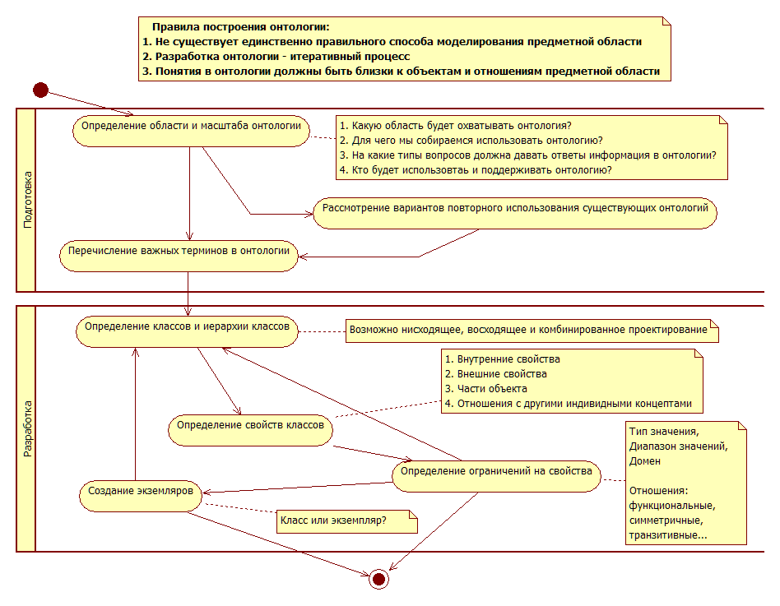

Занятие 4. Расширенные конструкции OWL

Complex Classes
By means of the language elements described so far, simple ontologies can be modeled. In order to express more complex knowledge, OWL provides logical class constructors. In particular, OWL provides language elements for logical and, or, and not. The corresponding OWL terms are borrowed from set theory: (class) intersection, union and complement. These constructors combine atomic classes – i.e. classes with names – to complex classes.
The intersection of two classes consists of exactly those individuals which are instances of both classes. The following example states that the class Mother consists of exactly those objects which are instances of both Woman and Parent:
EquivalentClasses(
:Mother
ObjectIntersectionOf( :Woman :Parent )
)
An example for an inference which can be drawn from this is that all instances of the class Mother are also in the class Parent.
The union of two classes contains every individual which is contained in at least one of these classes. Therefore we could characterize the class of all parents as the union of the classes Mother and Father:
EquivalentClasses(
:Parent
ObjectUnionOf( :Mother :Father )
)
The complement of a class corresponds to logical negation: it consists of exactly those objects which are not members of the class itself. The following definition of childless persons uses the class complement and also demonstrates that class constructors can be nested:
EquivalentClasses(
:ChildlessPerson
ObjectIntersectionOf(
:Person
ObjectComplementOf( :Parent )
)
)
All the above examples demonstrate the usage of class constructors in order to define new classes as combination of others. But, of course, it is also possible to use class constructors together with a subclass statement in order to indicate necessary, but not sufficient, conditions for a class. The following statement indicates that every Grandfather is both a man and a parent (whereas the converse is not necessarily true):
SubClassOf(
:Grandfather
ObjectIntersectionOf( :Man :Parent )
)
In general, complex classes can be used in every place where named classes can occur, hence also in class assertions. This is demonstrated by the following example which asserts that Jack is a person but not a parent.
ClassAssertion(
ObjectIntersectionOf(
:Person
ObjectComplementOf( :Parent )
)
:Jack
)

Property Restrictions
Property restrictions provide another type of logic-based constructors for complex classes. As the name suggests, property restrictions use constructors involving properties.
One property restriction called existential quantification defines a class as the set of all individuals that are connected via a particular property to another individual which is an instance of a certain class. This is best explained by an example, like the following which defines the class of parents as the class of individuals that are linked to a person by the hasChild property.
EquivalentClasses(
:Parent
ObjectSomeValuesFrom( :hasChild :Person )
)
This means that there is an expectation that for every instance of Parent, there exists at least one child, and that child is a member of the class Person. This is useful to capture incomplete knowledge. For example, Sally tells us that Bob is a parent, and therefore we can infer that he has at least one child even if we don't know their name. Natural language indicators for the usage of existential quantification are words like “some,” or “one.”
Another property restriction, called universal quantification is used to describe a class of individuals for which all related individuals must be instances of a given class. We can use the following statement to indicate that somebody is a happy person exactly if all their children are happy persons.
EquivalentClasses(
:HappyPerson
ObjectAllValuesFrom( :hasChild :HappyPerson )
)
This example also shows that OWL statements are allowed to be in a certain way self-referential; the class HappyPerson is used on both sides of the equivalence statement.
The usage of property restrictions may cause some conceptual confusion to “modeling beginners.” As a rule of thumb, when translating a natural language statement into a logical axiom, existential quantification occurs far more frequently. Natural language indicators for the usage of universal quantification are words like “only,” “exclusively,” or “nothing but.”
There is one particular misconception concerning the universal role restriction. As an example, consider the above happiness axiom. The intuitive reading suggests that in order to be happy, a person must have at least one happy child. Yet, this is not the case: any individual that is not a “starting point” of the property hasChild is a class member of any class defined by universal quantification over hasChild. Hence, by our above statement, every childless person would be qualified as happy. In order to formalize the aforementioned intended reading, the statement would have to read as follows:
EquivalentClasses(
:HappyPerson
ObjectIntersectionOf(
ObjectAllValuesFrom( :hasChild :HappyPerson )
ObjectSomeValuesFrom( :hasChild :HappyPerson )
)
)
This example also illustrates how property restrictions can be nested with complex classes.
Property restrictions can also be used to describe classes of individuals that are related to one particular individual. For instance we could define the class of John's children:
EquivalentClasses(
:JohnsChildren
ObjectHasValue( :hasParent :John )
)
As a special case of individuals being interlinked by properties, an individual might be linked to itself. The following example shows how to represent the idea that all narcissists love themselves.
EquivalentClasses(
:NarcisticPerson
ObjectHasSelf( :loves )
)

Property Cardinality Restrictions
Using universal quantification, we can say something about all of somebody's children, whereas existential quantification allows us to refer to (at least) one of them. However, we might want to specify the number of individuals involved in the restriction. Indeed, we can construct classes depending on the number of children. The following example states that John has at most four children who are themselves parents:
ClassAssertion(
ObjectMaxCardinality( 4 :hasChild :Parent )
:John
)
Note that this statement allows John to have arbitrarily many further children who are not parents.
Likewise, it is also possible to declare a minimum number by saying that John is an instance of the class of individuals having at least two children who are parents:
ClassAssertion(
ObjectMinCardinality( 2 :hasChild :Parent )
:John
)
If we happen to know the exact number of John's children who are parents, this can be specified as follows:
ClassAssertion(
ObjectExactCardinality( 3 :hasChild :Parent )
:John
)
In a cardinality restriction, providing the class is optional; if we just want to talk about the number of all of John's children we can write the following:
ClassAssertion(
ObjectExactCardinality( 5 :hasChild )
:John
)

Enumeration of Individuals
A very straightforward way to describe a class is just to enumerate all its instances. OWL provides this possibility, e.g. we can create a class of birthday guests:
EquivalentClasses(
:MyBirthdayGuests
ObjectOneOf( :Bill :John :Mary)
)
Note that this axiom provides more information than simply asserting class membership of Bill, John, and Mary as described in Section 4.1. In addition to that, it also stipulates that Bill, John, and Mary are the only members of MyBirthdayGuests. Therefore, classes defined this way are sometimes referred to as closed classes or enumerated sets. If we now assert Jeff as an instance of MyBirthdayGuests, the consequence is that Jeff must be equal to one of the above three persons.

Property Characteristics
Sometimes one property can be obtained by taking another property and changing its direction, i.e. inverting it. For example, the property hasParent can be defined as the inverse property of hasChild:
InverseObjectProperties( :hasParent :hasChild )
This would for example allow to deduce for arbitrary individuals A and B, where A is linked to B by the hasChild property, that B and A are also interlinked by the hasParent property. However, we do not need to explicitly assign a name to the inverse of a property if we just want to use it, say, inside a class expression. Instead of using the new hasParent property for the definition of the class Orphan, we can directly refer to it as the hasChild-inverse:

EquivalentClasses(
:Orphan
ObjectAllValuesFrom(
ObjectInverseOf( :hasChild )
:Dead
)
)
In some cases, a property and its inverse coincide, or in other words, the direction of a property doesn't matter. For instance the property hasSpouse relates A with B exactly if it relates B with A. For obvious reasons, a property with this characteristic is called symmetric, and it can be specified as follows
SymmetricObjectProperty( :hasSpouse )
On the other hand, a property can also be asymmetric meaning that if it connects A with B it never connects B with A. Clearly (excluding paradoxical scenarios resulting from time travels), this is the case for the property hasChild and is expressed like this:
AsymmetricObjectProperty( :hasChild )
Note that being asymmetric is a much stronger notion than being non-symmetric. Likewise, being symmetric is a much stronger notion than being non-asymmetric.
Previously, we considered subproperties in analogy to subclasses. It turns out that it also make sense to transfer the notion of class disjointness to properties: two properties are disjoint if there are no two individuals that are interlinked by both properties. Following common law, we can thus state that parent-child marriages cannot occur:
DisjointObjectProperties( :hasParent :hasSpouse )
Properties can also be reflexive: such a property relates everything to itself. For the following example, note that everybody has himself as a relative.
ReflexiveObjectProperty( :hasRelative )
Note that this does not necessarily mean that every two individuals which are related by a reflexive property are identical.
Properties can furthermore be irreflexive, meaning that no individual can be related to itself by such a role. A typical example is the following which simply states that nobody can be his own parent.
IrreflexiveObjectProperty( :parentOf )
Next, consider the hasHusband property. As every person can have only one husband (which we take for granted for the sake of the example), every individual can be linked by the hasHusband property to at most one other individual. This kind of properties are called functional and are described as follows:
FunctionalObjectProperty( :hasHusband )
Note that this statement does not require every individual to have a husband, it just states that there can be no more than one. Moreover, if we additionally had a statement that Mary's husband is James and another that Mary's husband is Jim, it could be inferred that Jim and James must refer to the same individual.
It is also possible to indicate that the inverse of a given property is functional:
InverseFunctionalObjectProperty( :hasHusband )
This indicates that an individual can be husband of at most one other individual. The example also indicates the difference between functionality and inverse functionality, as in a polygynous situation the former axiom is valid whereas the latter isn't.
Now have a look at a property hasAncestor which is meant to link individuals A and B whenever A is a direct descendant of B. Clearly, the property hasParent is a “special case” of hasAncestor and can be defined as a subproperty thereof. Still, it would be nice to "automatically" include parents of parents (and parents of parents of parents). This can be done by defining hasAncestor as transitive property. A transitive property interlinks two individuals A and C whenever it interlinks A with B and B with C for some individual B.
TransitiveObjectProperty( :hasAncestor )

Property Chains
While the last example from the previous section implied the presence of an hasAncestor property whenever there is a chain of hasParent properties, we might want to be a bit more specific and define, say, a hasGrandparent property instead. Technically, this means that we want hasGrandparent to connect all individuals that are linked by a chain of exactly two hasParent properties. In contrast to the previous hasAncestor example, we do not want hasParent to be a special case of hasGrandparent nor do we want hasGrandparent to refer to great-grandparents etc. We can express that every such chain has to be spanned by a hasGrandparent property as follows:
SubObjectPropertyOf(
ObjectPropertyChain( :hasParent :hasParent )
:hasGrandparent
)

Keys
In OWL 2 a collection of (data or object) properties can be assigned as a key to a class expression. This means that each named instance of the class expression is uniquely identified by the set of values which these properties attain in relation to the instance.
A simple example of this would be the identification of a person by her social security number.
HasKey( :Person () ( :hasSSN ) )

Advanced Use of Datatypes
First of all, data values are grouped into datatypes and we have seen in Section 4.8 how a range restriction on a datatype property can be used to indicate the kind of values this property can link to. Moreover, it is possible to express and define new datatypes by constraining or combining existing ones. Datatypes can be restricted via so-called facets, borrowed from XML Schema Datatypes [XML Schema Datatypes]. In the following example, we define a new datatype for a person's age by constraining the datatype integer to values between (inclusively) 0 and 150.
DatatypeDefinition(
:personAge
DatatypeRestriction( xsd:integer
xsd:minInclusive "0"^^xsd:integer
xsd:maxInclusive "150"^^xsd:integer
)
)
Likewise, datatypes can be combined just like classes by complement, intersection and union. Thereby, assuming we have already defined a datatype minorAge, we can define the datatype majorAge by excluding all data values of minorAge from personAge:
DatatypeDefinition(
:majorAge
DataIntersectionOf(
:personAge
DataComplementOf( :minorAge )
)
)

Moreover, a new datatype can be generated by just enumerating the data values it contains.
DatatypeDefinition(
:toddlerAge
DataOneOf( "1"^^xsd:integer "2"^^xsd:integer )
)
In Section 6.1, we saw ways of characterizing object properties. Some of those are also available for datatype properties. For example, we can express that every person has only one age by characterizing the hasAge datatype property as functional:
FunctionalDataProperty( :hasAge )
New classes can be defined by restrictions on datatype properties. The following example defines the class teenager as all individuals whose age is between 13 and 19 years.
SubClassOf(
:Teenager
DataSomeValuesFrom( :hasAge
DatatypeRestriction( xsd:integer
xsd:minExclusive "12"^^xsd:integer
xsd:maxInclusive "19"^^xsd:integer ) ) )

Annotating Axioms and Entities
In many cases, we want to furnish parts of our OWL ontology with information that actually does not describe the domain itself but talks about the description of the domain. OWL provides annotations for this purpose. An OWL annotation simply associates property-value pairs with parts of an ontology, or the entire ontology itself. Even annotations themselves can be annotated. Annotation information is not really part of the logical meaning of an ontology.
So, for example, we could add information to one of the classes of our ontology, giving a natural language description of its meaning.
AnnotationAssertion( rdfs:comment :Person "Represents the set of all people." )
The following is an example of an axiom with an annotation.
SubClassOf(
Annotation( rdfs:comment "States that every man is a person." )
:Man
:Person
)
Often such annotations are used in tools to provide access to natural language text to be displayed in help interfaces.

Keyword | Example | Intuitive Meaning
some | hasPet some Dog | Things that have a pet that is a Dog  This is the most common type of class expression. Also known as, an "SomeValueFrom restriction" or an "Existential Restriction". This kind of class expression consists of a property (in this case hasPet) and a class expression that is known as a filler (in this case the filler is Dog).  Individuals that are instances of this class expression have a relationship along the hasPet property to an individual that is an instance of class Dog.
value | hasPet value Tibbs | Things that have a pet that is Tibbs.  Here, Tibbs is a specific individual. Intuitively this would describe Tibb's owners. Note that this is a short cut for, and logically equivalent to, (hasPet some {Tibbs}), where the curly brackets describe a class of specific individuals - in this case, a class of one individual that is Tibbs. Also known as a "HasValue restriction"
only | hasPet only Cat | Things that have pets that are only Cats.  Note that this does not mean that these things must have a Cat, but if they do have a pet then it will be a Cat. Also known as an "AllValuesFrom restriction" or a "Universal restriction"
min | hasPet min 3 Cat | Things that have at least three pets that are Cats.  Things that have at least three pets that are Cats. Also known as a "Min cardinality restriction"
max | hasPet max 5 Dog | Things that have at most five pets that are Dogs.  Note that there may be more than five pets in total e.g. three Cats and five Dogs, but the number of Dogs will not be more than five. This class expression also means that there may be no pets at all. Also known as a "Max cardinality restriction"
exactly | hasPet exactly 2 GoldFish | Things that have exactly 2 GoldFish as pets.  Note that there may be more than two pets, but two of the pets are GoldFish - no more and no less. Also known as an "Exact cardinality restriction"
and | Person and (hasPet some Cat) | People that have a pet that's a Cat.  Here we have a class name and a complex class expression combined with the and keyword. The brackets are optional in this particular case, but have been included for clarity. Also known as an "Intersection" or a "Conjunction". We also say that each class expression in the conjunction is a "conjunct".
or | (hasPet some Cat) or (hasPet some Dog) | Things that have a pet that's a Cat or have a pet that's a Dog  Note that the or is not exclusive. That is, this class includes the things that have a Cat as a pet, or have a Dog as a pet, or have both a pet Dot and a pet Cat. Note that we could have also written this example as (hasPet some (Cat or Dog)) Also known as a "Union" or a "Disjunction". We also say that each class expression in the disjunction is a "disjunct".
not | not (hasPet some Dog) | Things that do not have a pet that's a dog.  This includes things that either do not have any pet, or if they have a pet then it's not a Dog. Note that this is logically equivalent to (hasPet only (not Dog)) Also known as a "negation".
Занятие 5. Профили языка OWL

There are two alternative ways of assigning meaning to ontologies in OWL 2 called the Direct Semantics and the RDF-Based Semantics. The Direct Semantics can be applied to ontologies that are in the OWL 2 DL subset of OWL 2, which is defined in OWL 2 functional-style syntax document. Ontologies that are not in OWL 2 DL are often said to belong to OWL 2 Full, and can only be interpreted under RDF-Based Semantics. Informally, the term OWL 2 DL is often used to refer to OWL 2 ontologies interpreted using the Direct Semantics, but it is also possible to interpret OWL 2 DL ontologies under RDF-Based Semantics.
The Direct Semantics provides a meaning for OWL 2 in a Description Logic style. The RDF-Based Semantics is an extension of the semantics for RDFS and is based on viewing OWL 2 ontologies as RDF graphs.
When thinking about ontologies the differences between these two semantics are generally quite slight. Indeed, given an OWL 2 DL ontology, many inferences drawn using the Direct Semantics remain valid inferences under the RDF-Based Semantics – see the correspondence theorem in Section 7.2 of the RDF-Based Semantics document. The two main differences are that under the Direct Semantics annotations have no formal meaning and under the RDF-Based Semantics there are some extra inferences that arise from the RDF view of the universe.
Conceptually, we can think of the difference between OWL 2 DL (under Direct Semantics) and OWL 2 Full (under RDF-Based Semantics) in two ways:
- One can see OWL 2 DL as a syntactically restricted version of OWL 2 Full where the restrictions are designed to make life easier for implementors. In fact, since OWL 2 Full (under the RDF-Based Semantics) is undecidable, OWL 2 DL (under the Direct Semantics) makes writing a reasoner that, in principle, can return all "yes or no" answers (subject to resource constraints) possible. As a consequence of its design, there are several production quality reasoners that cover the entire OWL 2 DL language under the Direct Semantics. There are no such reasoners for OWL 2 Full under the RDF-Based Semantics.
- One can see OWL 2 Full as the most straightforward extension of RDFS. As such, the RDF-Based Semantics for OWL 2 Full follows the RDFS semantics and general syntactic philosophy (i.e., everything is a triple and the language is fully reflective).
Of course, the two semantics have been designed together and thus have influenced each other. For example, one design goal of OWL 2 was to bring OWL 2 DL syntactically closer to OWL 2 Full (that is, to allow more RDF Graphs/OWL 2 Full ontologies to be legal OWL 2 DL ontologies). This led to the incorporation of so-called punning into OWL 2, e.g., using the same IRI as a name for both a class and an individual. An example of such usage would be the following, which states that John is a father, and that father is a social role.

ClassAssertion( :Father :John )
ClassAssertion( :SocialRole :Father )
Note that in the first statement, Father is used as a class, while in the second it is used as an individual. In this sense, SocialRole acts as a metaclass for the class Father.
In OWL 1, a document containing these two statements would be an OWL 1 Full document, but not an OWL 1 DL document. In OWL 2 DL, however, this is allowed. It must be noted, though, that the Direct Semantics of OWL 2 DL accommodates this by understanding the class Father and the individual Father as two different views on the same IRI, i.e. they are interpreted semantically as if they were distinct. In particular, if two individuals are equal, then the classes that they denote are equivalent under RDF-Based Semantics, whereas there is no such relationship between the classes under Direct Semantics. This is possibly the one difference between the two semantics that is most relevant in practice.

OWL 2 Profiles
In addition to OWL 2 DL and OWL 2 Full, OWL 2 specifies three profiles. OWL 2, in general, is a very expressive language (both computationally and for users) and thus can be difficult to implement well and to work with. These additional profiles are designed to be approachable subsets of OWL 2 sufficient for a variety of applications. As with OWL 2 DL, computational considerations are a major requirement of these profiles (and they are all much easier to implement with robust scalability given existing technology), but there are many subsets of OWL 2 that have good computational properties. The selected OWL 2 profiles were identified as having substantial user communities already, although there were several others not included and one should expect more to emerge. The [OWL 2 Profiles] document provides a clear template for specifying additional profiles.
In order to guarantee scalable reasoning, the existing profiles share some limitations regarding their expressiveness. In general, they disallow negation and disjunction, as these constructs complicate reasoning and have proved to be only rarely needed for modeling. For example, in none of the profiles it is possible to specify that every person is either male or female. Further specific modeling restrictions of the profiles will be dealt with in the sections on the individual profiles.
We discuss each profile and its design rationale, and provide some guidance for users in selecting which profile to work with. Please be aware that this discussion is not comprehensive, nor can it be. Part of any decision has to be based on available tooling and how that fits in with the rest of your system or workflow. A more extended discussion and comparison of the profiles can be found in the literature [OWL 2 Profiles Introduction].
By and large, different profiles can be distinguished syntactically, and some of the profiles contain others. For example, OWL 2 DL can be seen as a syntactic fragment of OWL 2 Full and OWL 2 QL is a syntactic fragment of OWL 2 DL (and thus of OWL 2 Full). None of these profiles below is a subset of another. Ideally, one can use a reasoner (or other tool) that is conforming for a superprofile on the subprofile with no change in the results derived. In particular, every conforming OWL 2 DL reasoner is also a conforming reasoner for OWL 2 EL, OWL 2 RL, and OWL 2 QL (but may differ in performance since the OWL 2 DL reasoner is tuned for a more general set of cases). Each of the two semantics of OWL 2 (see Section 9) can be used for any of the profiles, but it is most common to use Direct Semantics for OWL 2 EL and OWL 2 QL, and RDF-Based Semantics for OWL 2 RL.

10.1 OWL 2 EL
Working with OWL 2 EL is fairly similar to working with OWL 2 DL: one can use class expressions on both sides of a subClassOf statement and even infer such relations. For many large, class-expression oriented ontologies, by only a little simplification one can get an OWL 2 EL ontology and preserve the bulk of the meaning of the original ontology.
OWL 2 EL is designed with large biohealth ontologies in mind, such as SNOMED-CT, the NCI thesaurus, and Galen. Common characteristics of such ontologies include complex structural descriptions (e.g., defining certain body parts in terms of what parts they contain and are contained in or propagating diseases along part-subpart relations), huge numbers of classes, the heavy use of classification to manage the terminology, and the application of the resulting terminology to vast amounts of data. Thus, OWL 2 EL has a comparatively expressive class expression language and it has no restrictions on how they may be used in axioms. It also has fairly expressive property expressions, including property chains but excluding inverse.
Sensible use of OWL 2 EL is obviously not restricted to the biohealth domain: as with the other profiles, OWL 2 EL is domain independent. However, OWL 2 EL shines when your domain and your application require recognition of structurally complex objects. Such domains include system configurations, product inventories, and many scientific domains.
Besides negation and disjunction, OWL 2 EL also disallows universal quantification on properties. Therefore propositions like “all children of a rich person are rich” cannot be stated. Moreover, as all kinds of role inverses are not available, there is no way of specifying that, say, parentOf and childOf are inverses of each other.
The EL acronym reflects the profile's basis in the so-called EL family of description logics [EL++]; they are Languages providing mainly Existential quantification of variables.
The following is an example which uses some of the typical modeling features available in OWL 2 EL.
SubClassOf(
:Father
ObjectIntersectionOf( :Man :Parent )
)

EquivalentClasses(
:Parent
ObjectSomeValuesFrom(
:hasChild
:Person
)
)

EquivalentClasses(
:NarcisticPerson
ObjectHasSelf( :loves ) )

DisjointClasses(
:Mother
:Father
:YoungChild
)

SubObjectPropertyOf(
ObjectPropertyChain( :hasFather :hasBrother )
:hasUncle
)

NegativeObjectPropertyAssertion(
:hasDaughter
:Bill
:Susan
)

OWL 2 QL
OWL 2 QL can be realized using standard relational database technology (e.g., SQL) simply by expanding queries in the light of class axioms. This means it can be tightly integrated with RDBMSs and benefit from their robust implementations and multi-user features. Furthermore, it can be implemented without having to “touch the data,” so really as a translational/preprocessing layer. Expressively, it can represent key features of Entity-relationship and UML diagrams (at least those with functional restrictions). Thus, it is suitable both for representing database schemas and for integrating them via query rewriting. As a result, it can also be used directly as a high level database schema language, though users may prefer a diagram based syntax.
OWL 2 QL also captures many commonly used features in RDFS and small extensions thereof, such as inverse properties and subproperty hierarchies. OWL 2 QL restricts class axioms asymmetrically, that is, you can use constructs as the subclass that you cannot use as the superclass.
Among other constructs, OWL 2 QL disallows existential quantification of roles to a class expression, e.g. it can be stated that every person has a parent but not that every person has a female parent. Moreover property chain axioms and equality are not supported.
The QL acronym reflects the fact that query answering in this profile can be implemented by rewriting queries into a standard relational Query Language [DL-Lite].
The following is an example which uses some of the typical modeling features available in OWL 2 QL. The first axiom states that every childless person is a person for which there does not exist anybody who has the first person as parent.
SubClassOf(
:ChildlessPerson
ObjectIntersectionOf(
:Person
ObjectComplementOf(
ObjectSomeValuesFrom(
ObjectInverseOf( :hasParent )
owl:Thing
)
)
)
)

DisjointClasses(
:Mother
:Father
:YoungChild
)

DisjointObjectProperties(
:hasSon
:hasDaughter
)

SubObjectPropertyOf(
:hasFather
:hasParent
)

OWL 2 RL
The OWL 2 RL profile is aimed at applications that require scalable reasoning without sacrificing too much expressive power. It is designed to accommodate both OWL 2 applications that can trade the full expressivity of the language for efficiency, and RDF(S) applications that need some added expressivity from OWL 2. This is achieved by defining a syntactic subset of OWL 2 which is amenable to implementation using rule-based technologies, and presenting a partial axiomatization of the OWL 2 semantics in the form of first-order implications that can be used as the basis for such an implementation.
Suitable rule-based implementations of OWL 2 RL under RDF-Based Semantics can be used with arbitrary RDF graphs. As a consequence, OWL 2 RL is ideal for enriching RDF data, especially when the data must be massaged by additional rules. From a modeling perspective, however, this pushes us farther away from working with class expressions: OWL 2 RL ensures we cannot (easily) talk about unknown individuals in our superclass expressions (this restriction follows from the nature of rules). Compared with OWL 2 QL, OWL 2 RL works better when you have already massaged your data into RDF and are working with it as RDF.
Among other constructs, OWL 2 RL disallows statements where the existence of an individual enforces the existence of another individual: for instance, the statement “every person has a parent” is not expressible in OWL RL.
OWL 2 RL restricts class axioms asymmetrically, that is, you can use constructs as the subclass that you cannot use as the superclass.
The RL acronym reflects the fact that reasoning in this profile can be implemented using a standard Rule Language [DLP].
The following is an example which uses some of the typical modeling features available in OWL 2 RL. The first – somewhat contrived – axiom states that for each of Mary, Bill, and Meg who is female, the following holds: she is a parent with at most one child, and all her children (if she has any) are female.
SubClassOf(
ObjectIntersectionOf(
ObjectOneOf( :Mary :Bill :Meg )
:Female )
ObjectIntersectionOf(
:Parent
ObjectMaxCardinality( 1 :hasChild )
ObjectAllValuesFrom( :hasChild :Female )
)
)

DisjointClasses(
:Mother
:Father
:YoungChild
)

SubObjectPropertyOf(
ObjectPropertyChain( :hasFather :hasBrother )
:hasUncle
)

OWL Tools
In order to work with OWL ontologies, tool support is essential. Basically, there are two types of tools addressing the two main stages of the ontology lifecycle: ontology editors are used to create and edit ontologies, whereas reasoners are used to query ontologies for implicit knowledge, i.e., they determine whether a statement in question is a logical consequence of an ontology.
The currently most widely used OWL editor is Protégé, a free open-source editing framework developed at Stanford University. By virtue of its open plugin structure, it allows for the easy integration of special-purpose ontology editing components. Other editors include TopQuadrant's commercial TopBraid Composer and the open-source systems SWOOP and NeOn-Toolkit.
There are several reasoners for OWL DL which differ somewhat in terms of coverage of the supported reasoning features. For some of these, OWL 2 conformance is currently planned and the corresponding implementations are in progress. The Test Suite Status document lists to which extent some of the reasoners mentioned below comply with the test cases.
For reasoning within OWL DL, the most prominent systems are Fact++ by the University of Manchester, Hermit by Oxford University Computing Laboratory, Pellet by Clark & Parsia, LLC, and RacerPro by Racer Systems.
In addition to those general-purpose reasoners aiming at supporting all of OWL DL, there are reasoning systems tailored to the tractable profiles of OWL. CEL by Dresden University of Technology supports OWL EL. QuOnto by Sapienza Università di Roma supports OWL QL. ORACLE 11g supports OWL RL.
The open-source OWL API plays a rather prominent role as the currently most important development tool around OWL.
Занятие 6. Язык запросов SPARQL

http://shcherbak.net/translations/ru_sparql_shcherbak_net.html – W3C, 15.01.2008

SPARQL используется для представления запросов к разнообразным источникам данных, независимо от того, хранятся эти данные непосредственно в RDF либо представляются в виде RDF с помощью промежуточного программного обеспечения (middleware). SPARQL обладает возможностями формирования запросов к обязательным и необязательным графовым шаблонам вместе с их конъюнкциями и дизъюнкциями. SPARQL также поддерживает тестирование расширенного значения и ограничение запросов посредством исходного RDF-графа. Результаты запросов SPARQL могут быть представлены результирующими наборами или RDF-графами.
Большая часть запросов SPARQL включает набор шаблонов триплетов, который называется основным графовым шаблоном. Шаблоны триплетов похожи на RDF-триплеты, за исключением того, что каждый субъект, предикат и объект может быть переменной. Основной графовый шаблон соответствует подграфу RDF-данных, когда RDF-термины этого подграфа могут быть заменены переменными, а результат является RDF-графом, эквивалентным подграфу.
PREFIX sbks: <http://wiki.kubsu.ru:8080/owlp/OntologySBKS.owl#>
SELECT *
FROM <http://wiki.kubsu.ru:8080/owlp/OntologySBKS.owl>
WHERE {
?element sbks:hasName ?roleName.
?element sbks:hasRoleType ?roleType.
}
PREFIX foaf: <http://xmlns.com/foaf/0.1/>
SELECT ?name ?mbox
WHERE
{ ?x foaf:name ?name .
?x foaf:mbox ?mbox }
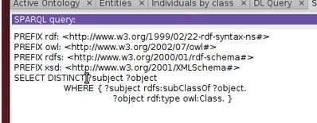
В SPARQL есть несколько форм запросов. Форма запроса SELECT возвращает привязки переменных. Форма запроса CONSTRUCT возвращает RDF-граф. Граф строится на базе шаблона, который применяется для генерации RDF-триплетов на основе результатов соответствия графовому шаблону запроса.
Соответствие графовому шаблону приводит к последовательности решений, где каждое решение имеет набор привязок переменных к RDF-терминам. SPARQL-фильтры (FILTER) накладывают ограничения на эти решения, пропуская лишь те решения, при которых значение выражения фильтра принимает значение TRUE.
Функции SPARQL-фильтров, например, regex, позволяют тестировать RDF-литералы. Функция regex соответствует только простым (plain) литералам без тега языка. Эта функция может применяться для соответствия лексическим формам других литералов, используя функцию str .

Запрос:
PREFIX dc: <http://purl.org/dc/elements/1.1/>
SELECT ?title
WHERE { ?x dc:title ?title
FILTER regex(?title, "^SPARQL") ////regex(str(?mbox), "@work.example")
}
Фильтры SPARQL могут накладывать ограничения на арифметические выражения.
Запрос:
PREFIX dc: <http://purl.org/dc/elements/1.1/>
PREFIX ns: <http://example.org/ns#>
SELECT ?title ?price
WHERE { ?x ns:price ?price .
FILTER (?price < 30.5)
?x dc:title ?title . }
Кроме числовых типов, SPARQL поддерживает xsd:string, xsd:boolean и xsd:dateTime
SPARQL основан на установлении соответствия графовому шаблону. Более сложные графовые шаблоны могут быть сформированы путем объединения меньших шаблонов. Существуют различные способы компоновки графовых шаблонов:
- Основные графовые шаблоны, где должен соответствовать набор шаблонов триплетов
- Групповой графовый шаблон, где должен соответствовать набор графовых шаблонов
- Необязательные графовые шаблоны, где дополнительные шаблоны могут расширять решение
- Альтернативный графовый шаблон, где могут использоваться два или более возможных варианта шаблонов
- Шаблоны поименованных графов, где шаблоны соответствуют поименованным графам

Основные графовые шаблоны представлены наборами шаблонов триплетов. Соответствие графовому шаблону SPARQL определено в терминах объединения результатов соответствия основным графовым шаблонам. Последовательность шаблонов триплетов, ограниченных фильтром, составляет единый основной графовый шаблон. Любой графовый шаблон в конце концов представляется в виде основного графового шаблона.
Необязательные составляющие графового шаблона могут быть определены синтаксически при помощи ключевого слова OPTIONAL, применимого к графовому шаблону:

PREFIX foaf: <http://xmlns.com/foaf/0.1/>
SELECT ?name ?mbox
WHERE { ?x foaf:name ?name .
OPTIONAL { ?x foaf:mbox ?mbox }
}
PREFIX dc: <http://purl.org/dc/elements/1.1/>
PREFIX ns: <http://example.org/ns#>
SELECT ?title ?price
WHERE { ?x dc:title ?title .
OPTIONAL { ?x ns:price ?price . FILTER (?price < 30) }
}
SPARQL предлагает средства компоновки графовых шаблонов так, чтобы поиск соответствия мог вестись для нескольких альтернативных графовых шаблонов. Если более одной альтернативы соответствуют, то находятся все возможные решения шаблонов. Альтернативы шаблонов синтаксически определяются при помощи ключевого слова UNION.
Запрос:
PREFIX dc10: <http://purl.org/dc/elements/1.0/>
PREFIX dc11: <http://purl.org/dc/elements/1.1/>

SELECT ?title
WHERE { { ?book dc10:title ?title } UNION { ?book dc11:title ?title } }
Ключевые слова FROM и FROM NAMED позволяют запросу определить набор данных RDF по ссылке. Эти ключевые слова указывают на то, что набор данных должен включать графы, полученные из представлений ресурсов, определенных посредством заданных IRI (т. е. абсолютная форма заданных IRI-ссылок). Набор данных, полученный в результате из нескольких условий FROM и FROM NAMED, является
PREFIX foaf: <http://xmlns.com/foaf/0.1/>
SELECT ?name
FROM <http://example.org/foaf/aliceFoaf>
WHERE { ?x foaf:name ?name }
При выполнении запросов к коллекции графов используется ключевое слово GRAPH для соответствия шаблонам поименованных графов. GRAPH может позволять IRI выбирать один граф либо использовать переменную, которая будет распространяться на IRI всех поименованных графов в наборе RDF-данных запроса. Применение ключевого слова GRAPH меняет активный граф для соответствия основным графовым шаблонам внутри части запроса. Если GRAPH не используется, в таком случае граф по умолчанию используется для соответствия основным графовым шаблонам.

PREFIX foaf: <http://xmlns.com/foaf/0.1/>

SELECT ?src ?bobNick
FROM NAMED <http://example.org/foaf/aliceFoaf>
FROM NAMED <http://example.org/foaf/bobFoaf>
WHERE
{
GRAPH ?src
{ ?x foaf:mbox <mailto:bob@work.example> .
?x foaf:nick ?bobNick
}
}
Шаблоны запроса генерируют неупорядоченную коллекцию решений. Каждое решение является частичной функцией переменных от RDF-терминов. Впоследствии с этими решениями оперируют, как с последовательностью (последовательностью решений), исходно неупорядоченной. Любые модификаторы последовательности впоследствии используются для создания другой последовательности. И, наконец, эта последняя последовательность применяется для генерации одного из результатов формы запроса SPARQL.
Модификатор последовательности решений является:
- Модификатором последовательности (Order): упорядочивает решения
- Модификатором проекции (Projection): выбирает определенные переменные
- Модификатором уникальности (Distinct): гарантирует уникальность решений в последовательности
- Модификатором сокращения (Reduced): разрешает элиминацию некоторых неуникальных решений
- Модификатором сдвига (Offset): контролирует, где начинаются решения во всей последовательности решений
- Модификатором предела (Limit): ограничивает число решений
Последовательность применения модификаторов совпадает с последовательностью вышеприведенного списка.
Условие ORDER BY устанавливает порядок последовательности решений За условием ORDER BY расположены компараторы последовательности, состоящие из выражения и необязательного модификатора последовательности (ASC() либо DESC()). Каждый компаратор последовательности является либо восходящим (ascending), — обозначается модификатором ASC() или отсутствием модификатора — либо нисходящим (descending) — обозначается модификатором DESC().
PREFIX foaf: <http://xmlns.com/foaf/0.1/>
SELECT ?name
WHERE { ?x foaf:name ?name }
ORDER BY ?name
PREFIX : <http://example.org/ns#>
PREFIX foaf: <http://xmlns.com/foaf/0.1/>
PREFIX xsd: <http://www.w3.org/2001/XMLSchema#>

SELECT ?name
WHERE { ?x foaf:name ?name ; :empId ?emp }
ORDER BY DESC(?emp)
PREFIX foaf: <http://xmlns.com/foaf/0.1/>

SELECT ?name
WHERE { ?x foaf:name ?name ; :empId ?emp }
ORDER BY ?name DESC(?emp)
При отсутствии модификаторов запроса DISTINCT или REDUCED повторные решения останутся в последовательности решений. Модификатор решений DISTINCT позволяет ликвидировать повторные решения. В частности, каждое решение, которое связывает одинаковые переменные и одинаковые RDF-термины в качестве еще одного решения, ликвидируется из набора решений. Тогда как модификатор DISTINCT обеспечивает элиминацию повторных решений из набора решений, REDUCED просто разрешает ликвидацию этих решений.
OFFSET позволяет сгенерированным решениям начинаться после определенного числа решений. Равенство OFFSET нулю не возымеет никакого эффекта. Использование LIMIT и OFFSET для выбора разных подмножеств решений запроса не имеет никакого смысла, если последовательность решений не предсказуема и не применен модификатор ORDER BY.
PREFIX foaf: <http://xmlns.com/foaf/0.1/>

SELECT ?name
WHERE { ?x foaf:name ?name }
ORDER BY ?name
LIMIT 5
OFFSET 10
Условие LIMIT задает верхнюю границу числа возвращаемых решений. Если фактическое число решений превышает лимит, то число возвращаемых решений не превысит заданный лимит.
PREFIX foaf: <http://xmlns.com/foaf/0.1/>

SELECT ?name
WHERE { ?x foaf:name ?name }
LIMIT 20
В SPARQL существует четыре формы запросов. Эти формы запроса используют решения исходя из соответствия шаблону для формирования результирующих наборов или RDF-графов. Ниже приведены эти формы запроса:
SELECT Возвращает все или подмножество переменных, связанных c соответствующим шаблоном запроса.
CONSTRUCT Возвращает RDF-граф, созданный путем замены переменных в наборе шаблонов триплетов.
PREFIX foaf: <http://xmlns.com/foaf/0.1/>
PREFIX vcard: <http://www.w3.org/2001/vcard-rdf/3.0#>
CONSTRUCT { <http://example.org/person#Alice> vcard:FN ?name }
WHERE { ?x foaf:name ?name }

Результат:
@prefix vcard: <http://www.w3.org/2001/vcard-rdf/3.0#> .
<http://example.org/person#Alice> vcard:FN "Alice" .

ASK Возвращает булево значение, которое указывает, соответствует ли шаблон запроса.
PREFIX foaf: <http://xmlns.com/foaf/0.1/>
ASK { ?x foaf:name "Alice" }

DESCRIBE Возвращает RDF-граф, описывающий найденные ресурсы.
DESCRIBE <http://example.org/>

PREFIX foaf: <http://xmlns.com/foaf/0.1/>
DESCRIBE ?x
WHERE { ?x foaf:mbox <mailto:alice@org> }

Форма DESCRIBE возвращает единственный результирующий RDF-граф, который содержит RDF-данные о ресурсах. Эти данные не предписаны запросом SPARQL, где клиенту запроса необходимо знать структуру RDF в источнике данных. Однако вместо этого данные определены обработчиком SPARQL-запроса. Шаблон запроса используется для создания результирующего набора. Форма DESCRIBE берет каждый из ресурсов, установленных в решении, вместе с любыми ресурсами, непосредственно названных по IRI, и формирует единый RDF-граф, взяв описание (description), которое может поступить из любой доступной информации, в том числе и из целевого набора данных RDF. Описание определяется сервисом запросов. Синтаксис DESCRIBE * является сокращением и обозначает все переменные в запросе.

Тестирование значений
Фильтры SPARQL (FILTER) ограничивают решения соответствия графовому шаблону ввиду заданого выражения. В частности, ключевые слова FILTER элиминируют любые решения, которые при замене на выражение либо приводят к эффективному булевому значению false, либо порождают ошибку.
- Числовой (numeric) обозначает типизированные литералы с типами данных xsd:integer, xsd:decimal, xsd:float, and xsd:double.
- простой (simple) литералобозначает простой литерал (plain literal) без тега языка.
- RDF-термин обозначает типы IRI, литерал literal и безымянная вершина(blank node).
Занятие 7. SWRL, SPARQL и др. Плагины

Semantic Web Rule Language (SWRL) – это технология, которая основана на объединении OWL и RuleML, т.е. объединены онтологии (OWL-DL) и правила.

Атомы в SWRL определены следующим образом:
где
C(i) – класс;
D(v) – тип данных;
R(i,j) – объектное свойство;
U(i,v) – свойства – типы данных (определяет связь);
p – встроенное отношение;
i,j – переменные, конкретные экземпляры или значения данных;
v1, …, vN – типы данных переменных или типы данных значений.

The OWL 2 language is not able to express all relations. One know example is that it cannot express the relation child of married parents, because there is no way in OWL 2 to express the relation between individuals with which an individual has relations.
The expresivity of OWL can be extended by adding SWRL (Semantic Web Rule Language) rules to an ontology. SWRL rules are similar to rules in Prolog or DATALOG languages. In fact, SWRL rules are DATALOG rules with unary predicates for describing classes and data types, binary predicates for properties, and some special built-in n-ary predicates. (See the section SWRL predicates for details)
Protege OWL editor supports SWRL rules, and the reasoners Pellet and Hermit also support SWRL rules.
We can add a SWRL rule saying that an individual X from the Person class, which has parents Y and Z such that Y has spouse Z, belongs to a new class ChildOfMarriedParents. Such rule is best described in the Protege syntax:
Person(?x), hasParent(?x, ?y), hasParent(?x, ?z), hasSpouse(?y, ?z) -> ChildOfMarriedParents(?x)

SWRL rules can use other predicates than just class or property names. The predicates can be
- class expressions - arbitrary class expressions, not just named classes
- property expressions - the only operator available in OWL 2 for creating property expresions is inverse of object property, however the same effect can be achieved by exchanging the property arguments, so there is no need to use property expressions in SWRL
- data range restrictions - specifies type of data value, like integer, date, union of some XML Schema types, enumerated type
- sameIndividual and differentIndividuals - for specifying sama and different individuals
- core SWRL built-ins - special predicates defined in SWRL proposal which can manipulate data values, for example to add numbers
- custom SWRL built-ins - you can define your own built-ins using Java code

Class expressions:
Person(?x), hasChild min 1 Person(?x) -> Parent(?x)
Range restrictions:
Person(?p), integer[>= 18 , <= 65](?age), hasAge(?p, ?age)
-> hasDriverAge(?p, true)
example: ((integer[>=1,<=2] or integer[>5,<7]) and not ({0}))(?y)
Core Built-ins:
Person(?p), hasAge(?p, ?age), swrlb:greaterThan(?age, 18) -> Adult(?p)
Person(?p), bornOnDate(?p, ?date), xsd:date(?date),
swrlb:date(?date, ?year, ?month, ?day, ?timezone) -> bornInYear(?p, ?year)

Custom built-ins

Person(?p), bornInYear(?p, ?year), my:thisYear(?nowyear),
swrlb:subtract(?age, ?nowyear, ?year) -> hasAge(?p, ?age)

my — определяется в специальном классе

Being a fragment of first order predicate logic, the DL cannot express the following:
- fuzzy expressions - “It often rains in autumn.”
- non-monotonicity - “Birds fly, penguin is a bird, but penguin does not fly.”
- propositional attitudes - “Eve thinks that 2 is not a prime number.” (It is true that she thinks it, but what she thinks is not true.)
- modal logic
  - possibility and necessity - “It is possible that it will rain today.”
  - epistemic modalities - “Eve knows that 2 is a prime number.”
  - temporal logic - “I am always hungry.”
  - deontic logic - “You must do this.”

Ontop — db to owl mapping. The Hello World SQL database.

The HelloWorld database has a very simple structure where it consists of two tables with a small set of data in it.
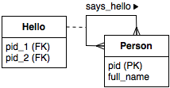
The dummy data:
Table: person
pid | full_name
ID001 | John Smith
ID002 | Mary Smith
ID003 | Adam Doe

Table: says_hello
pid_1 | pid_2
ID001 | ID002
ID003 | ID002

This simple database will be the data source for our ontology-based data access (OBDA) system.

Create a new OWL Ontology
Now we will create a small ontology that will accommodate the database. We are using Protégé 4.1 to construct the ontology. On the splash screen, click "Create new OWL ontology" and leave the default Ontology IRI given by Protégé. Give our ontology a name HelloWorld.owl on the next screen and accept the format as RDF/XML. Click "Finish" and you will get the following open window:

We now start constructing the ontology by defining the Classes , Object properties, and Data properties. First, let's create a Person, class. Go to the "Classes" tab and click on "Add subclass" icon and type "Person" in the dialog box.
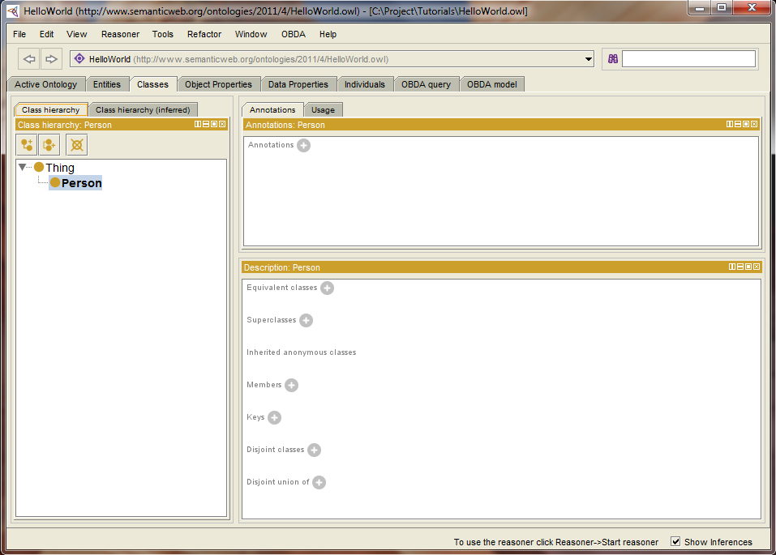

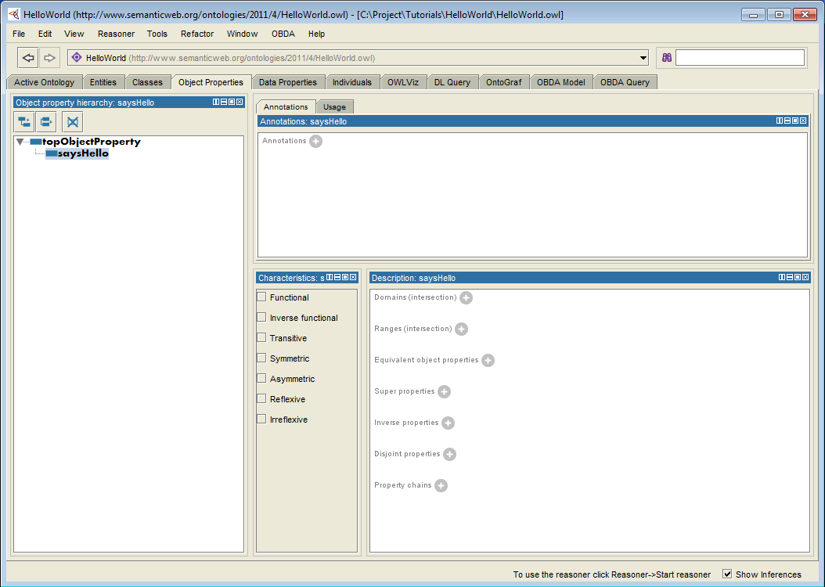
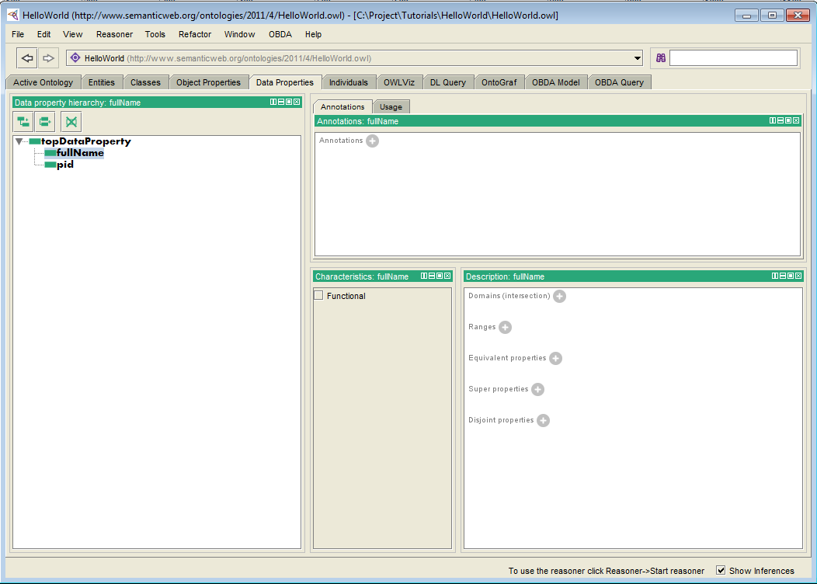

Define the Data Source
Defining a data source using -ontopPro- works as follows:
- Select the "ontop Mappings" tab.
- Go to "Datasource Manager" sub-tab and click on the "Create New..." button.
- Type "HelloWorld" as the ID for the data source (any name will do).
- Fill in the JDBC connection parameters according to our tutorial database configuration:
  - Connection URL: jdbc:h2:tcp://localhost/helloworld;DATABASE_TO_UPPER=FALSE
  - Database Username: sa
  - Database Password: (blank)
  - Driver class: org.h2.Driver
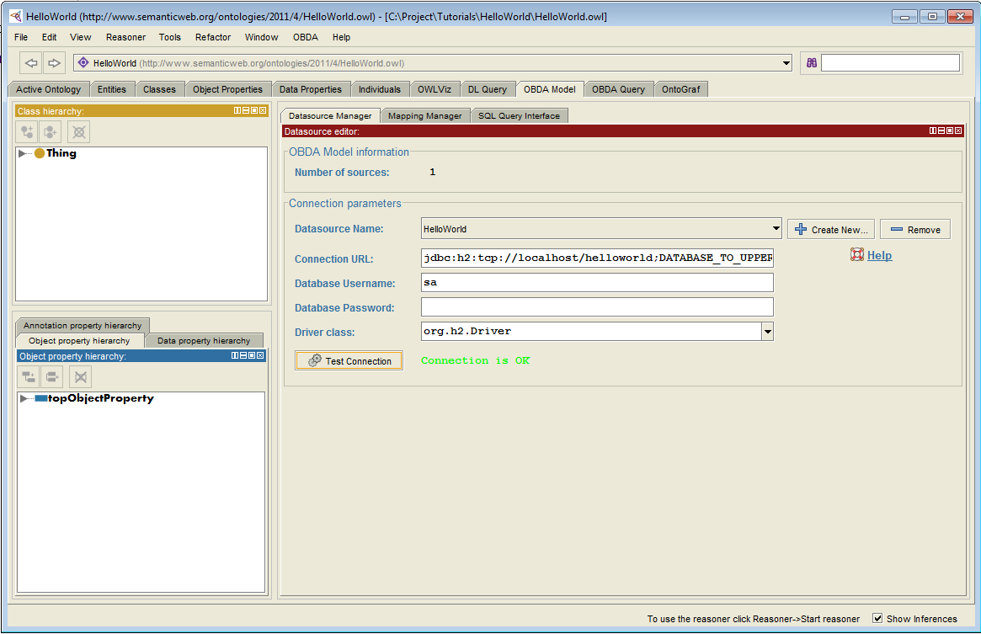

Create new Mappings
Now we will define the mapping assertions that will tell the reasoner how the data in the data source relates to the classes and properties in the ontology. Creating mappings using -ontopPro- works as follows:
- Still inside the "ontop Mappings" tab, go to the "Mappings Manager" sub-tab and select the data source we just defined.
- Click the "Create" button. This action will launch a new dialog window.
- Type the following triple graph in the Target (Triple Template) field. The string indicates how to construct triples using the data returned by the SQL query. Notice the {pid} variable that refers to the pid column name in the previous SQL query.
:Person-{pid} a :Person .
- Next, type the following SQL query in the Source (SQL Query) field that returns all PID entries from table Person. You can check the returned date by clicking the "Test SQL Query" button (shortcut CTRL+T). Please note that the casing of the query may change from one database engine to another. With H2, the query looks as follows:

SELECT "pid" FROM "person"
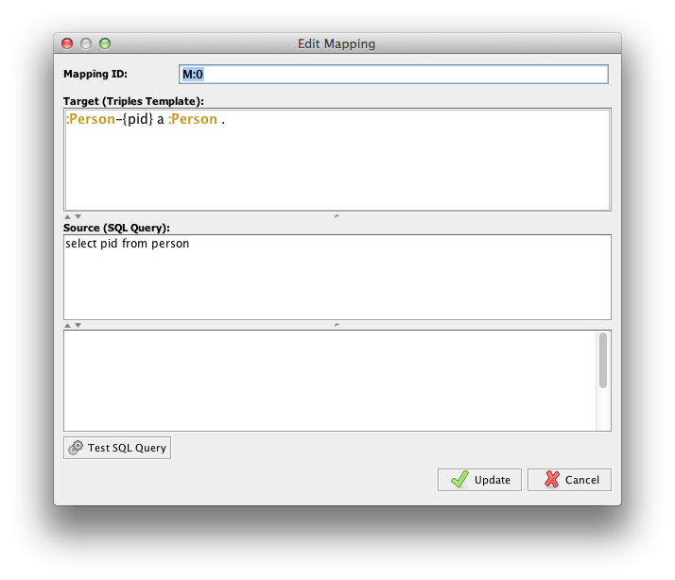

Repeat the above steps to create two additional mappings. Note : The table cells below indicate Source (SQL Query) --> Target (Triple Template)
:Person-{pid_1} :saysHello :Person-{pid_2} .
select "pid_1", "pid_2" from "says_hello"
:Person-{pid} :fullName {full_name} .
select "pid", "full_name" from "person"
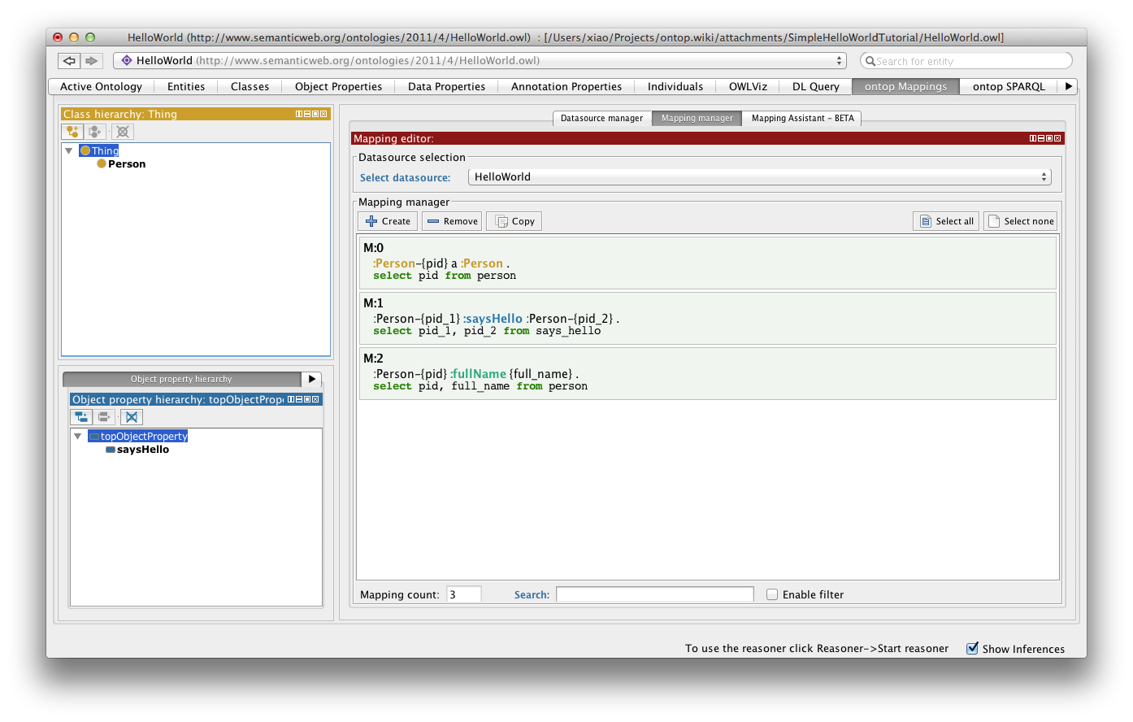
TIP: You can write any SQL query in the "Source" field including the one that uses WHERE and JOINs clauses. For the "Target" string, the syntax is similar to RDF Turtle. To learn more about -ontop- mappings see our documentation on mappings.

Executing SPARQL Queries
The plugin -ontopPro- uses Quest to answer SPARQL queries over the OBDA model (i.e., all the artifacts: ontology, data source and mapping assertions).

Preparations
We are going to execute the query using the Virtual RDF Graph mode. Put this setting as follows:
- Open Protégé preferences window: File > Preferences...
- Select "Quest" tab
- On the "Data Configuration" panel, select 'Virtual ABox mode (virtual RDF graph)'
Now we can start Quest reasoner as follows:
- Select "Reasoner" on the Protégé menu bar and select "Quest 1.7-alpha",
- Select "Start reasoner" immediately.
TIP: Once Quest is started, any changes in the ontology or mappings can only take its effect after you rerun the reasoner. Use "Synchronize reasoner" to do so.

Execution
Go to "ontop SPARQL" tab and create a new query as follows:
- In the "ontop query editor" panel, click the "Attach Prefixes" button. This action will bring out a dialog box to add any relevant prefix definitions in the query.
- Select the : and the rdf prefix and click "Accept".
- Type the query string as shown below and put it after the prefix definitions.
select distinct ?x where {?x rdf:type :Person}
- Click "Execute" to retrieve the result.
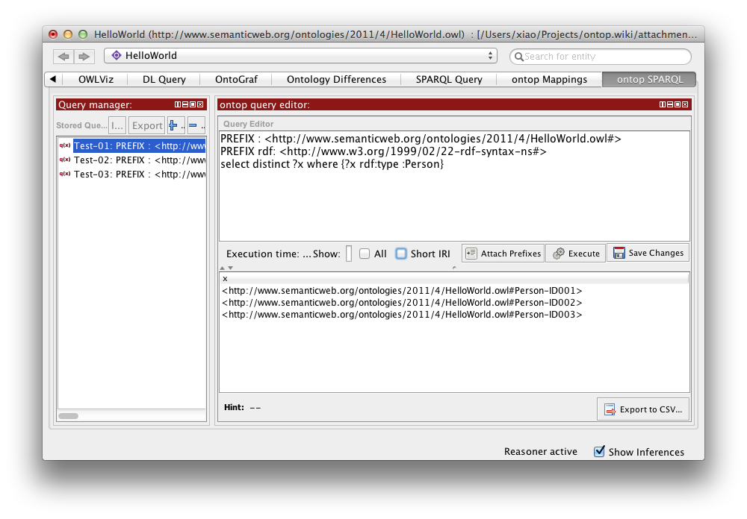
- Click "Save Changes" to remember the query.
TIP: Quest answers SPARQL queries by translating them into SQL query and then executing it through the DBMS system. If you would like to see the SQL string generated by Quest, do a right click over the query. Select "Get expended/unfolded query for this UCQ" on the pop-up menu.

Some other query suggestions:
- Get all DISTINCT full names.
PREFIX : <http://www.semanticweb.org/ontologies/2011/4/HelloWorld.owl#>
PREFIX rdf: <http://www.w3.org/1999/02/22-rdf-syntax-ns#>
SELECT DISTINCT ?x ?y WHERE {?x rdf:type :Person. ?x :fullName ?y}
- Get the full name of people who greets whom.
PREFIX : <http://www.semanticweb.org/ontologies/2011/4/HelloWorld.owl#>
PREFIX rdf: <http://www.w3.org/1999/02/22-rdf-syntax-ns#>
select ?x ?y where {?a :saysHello ?b. ?a :fullName ?x. ?b :fullName ?y}

Saving/Loading Mappings and Queries
-ontopPro- will automatically save your mappings and queries every time you do save file in Protégé. The mappings are stored in *.obda file and the queries are stored in a *.q file. Both are located in the same folder as the ontology with names correspond to the ontology file's name.
When opening an ontology, -ontopPro- will look for the .obda and .q files and loads the saved information regarding the data sources, mappings and queries.
If you would like to learn more about the syntax of .obda and .q files, find the introduction here and here.
TIP: The OBDA and Q files can also be loaded programmatically in Java using a separated API package.

Занятие 8. JENA

JENA — Java API, применяемое для создания и манипулирования RDF-графами. Объекты JENA представляют графы, ресурсы, свойства и литералы. Для этого созданы специальные интерфейсы. Граф представляется моделью.

String personURI = "http://somewhere/JohnSmith";
String givenName = "John";
String familyName = "Smith";
String fullName = givenName + " " + familyName;
Model model = ModelFactory.createDefaultModel();
Resource johnSmith = model.createResource(personURI)
.addProperty(VCARD.FN, fullName)
.addProperty(VCARD.N,
model.createResource()
.addProperty(VCARD.Given, givenName)
.addProperty(VCARD.Family, familyName));

mainOM = ModelFactory.createOntologyModel(OntModelSpec.OWL_MEM, null);

В примере представлено создание пустой модели по умолчанию хранимой в памяти. Помимо этого, существует набор других моделей. Например, модель owl-онтологии или модель представления в реляционной базе данных. Данные типы доступны так же через ModelFactory.

Каждое ребро графа называется выражением. Каждое выражение отражает некоторый факт и представляется в виде тройки: субъект, предикат, объект. Модель хранит множество таких троек. Метод listStatements() возвращает итератор, позволяющий перебрать все тройки в модели. StmtIterator содержит метод nextStatement() Интерфейс Statement позволяет получить доступ к тройке RDF.

StmtIterator iter = model.listStatements();
while (iter.hasNext()) {
Statement stmt = iter.nextStatement(); // get next statement
Resource subject = stmt.getSubject(); // get the subject
Property predicate = stmt.getPredicate(); // get the predicate
RDFNode object = stmt.getObject(); // get the object
System.out.print(subject.toString());
System.out.print(" " + predicate.toString() + " ");
if (object instanceof Resource) {
System.out.print(object.toString());
} else {
// object is a literal
System.out.print(" \"" + object.toString() + "\"");
}
System.out.println(" .");
}

Объект выражения может быть ресурсом либо литералом. Метод getObject() возвращает объект типа RDFNode, суперклассами которого являются и Resource и Literal.

Запись RDF

model.write(System.out); - пишет с ошибками, например, не пишет пустые. Можно указать любой поток вывода, например, вывод в файл. JENA поддерживает различные форматы записи в выходящий поток. Например,

model.write(System.out, "RDF/XML-ABBREV"); - пишет красиво
model.write(System.out, "N-TRIPLE");

Чтение RDF

Model model = ModelFactory.createDefaultModel();
// use the FileManager to find the input file
InputStream in = FileManager.get().open( inputFileName );
if (in == null) {
throw new IllegalArgumentException(
"File: " + inputFileName + " not found");
}
// read the RDF/XML file
model.read(in, null);
// write it to standard out
model.write(System.out);

Контроль префиксов

Для контроля префиксов используется механизм prefix mappings.

Model m = ModelFactory.createDefaultModel();
String nsA = "http://somewhere/else#";
String nsB = "http://nowhere/else#";
Resource root = m.createResource( nsA + "root" );
Property P = m.createProperty( nsA + "P" );
Property Q = m.createProperty( nsB + "Q" );
Resource x = m.createResource( nsA + "x" );
Resource y = m.createResource( nsA + "y" );
Resource z = m.createResource( nsA + "z" );
m.add( root, P, x ).add( root, P, y ).add( y, Q, z );
System.out.println( "# -- no special prefixes defined" );
m.write( System.out );
System.out.println( "# -- nsA defined" );
m.setNsPrefix( "nsA", nsA );
m.write( System.out );
System.out.println( "# -- nsA and cat defined" );
m.setNsPrefix( "cat", nsB );
m.write( System.out );

Навигация по модели

Для получения ресурса по его URI используется метод: Model.getResource(String uri). Данный метод возвращает ресурс, если он есть, и создаёт новый, если ресурса нет.

// retrieve the John Smith vcard resource from the model
Resource vcard = model.getResource(johnSmithURI);

Ресурс предлагает несколько методов, позволяющих получить доступ его свойствам: Resource.getProperty(Property p) — возвращает свойство как выражение (тройку), а не в смысле ООП.

// retrieve the value of the N property
Resource name = (Resource) vcard.getProperty(VCARD.N).getObject();
// retrieve the value of the FN property
Resource name = vcard.getProperty(VCARD.N).getResource();
// retrieve the given name property
String fullName = vcard.getProperty(VCARD.FN).getString();

Необходимо помнить, что у свойства может быть несколько значений.

// add two nickname properties to vcard
vcard.addProperty(VCARD.NICKNAME, "Smithy")
.addProperty(VCARD.NICKNAME, "Adman");

В связи с этим необходимо применять метод: Resource.listProperties(Property p). Данный метод возвращает итератор, содержащий выражения (т.е. Statement).

// set up the output
System.out.println("The nicknames of \"" + fullName + "\" are:");
// list the nicknames
StmtIterator iter = vcard.listProperties(VCARD.NICKNAME);
while (iter.hasNext()) {
System.out.println(""+ iter.nextStatement().getObject().toString());
}

Все свойства ресурса могут быть получены с использованием метода: listProperties()

Запросы к модели

Самое простое — перебрать значения итератора:

// list vcards
ResIterator iter = model.listSubjectsWithProperty(VCARD.FN);
while (iter.hasNext()) {
Resource r = iter.nextResource();
...
}

Любые запросы к модели есть упрощения базового запроса: model.listStatements(Selector s). Данный метод возвращает итератор в соответсвии с селектором. Интерфейс селектора может быть расширен. В пакете com.hp.hpl.jena.rdf.model содержится только один селектор: SimpleSelector. Использование данного селектора происходит редко
Конструктор:

Selector selector = new SimpleSelector(subject, predicate, object)

Данный селектор выбирает выражения (тройки), соответствующие заданным параметрам субъекта, предиката и объекта

Selector selector = new SimpleSelector(null, null, null);
Selector selector = new SimpleSelector(null, VCARD.FN, null);
listStatements( S, P, O )

is equivalent to

listStatements( new SimpleSelector( S, P, O )

// select all the resources with a VCARD.FN property
ResIterator iter = model.listSubjectsWithProperty(VCARD.FN);
if (iter.hasNext()) {
System.out.println("The database contains vcards for:");
while (iter.hasNext()) {
System.out.println(" " + iter.nextStatement()
.getProperty(VCARD.FN)
.getString());
}
} else {
System.out.println("No vcards were found in the database");
}

В данном примере переопределён базовый селектор и добавлена фильтрация карточек по окончанию имени:

// select all the resources with a VCARD.FN property
// whose value ends with "Smith"
StmtIterator iter = model.listStatements(
new SimpleSelector(null, VCARD.FN, (RDFNode) null) {
public boolean selects(Statement s)
{return s.getString().endsWith("Smith");}
});

Ещё пример:

// do all filtering in the selects method
StmtIterator iter = model.listStatements(
new
SimpleSelector(null, null, (RDFNode) null) {
public boolean selects(Statement s) {
return (subject == null || s.getSubject().equals(subject))
&& (predicate == null || s.getPredicate().equals(predicate))
&& (object == null || s.getObject().equals(object))
}
}
});
is equivalent to:
StmtIterator iter =
model.listStatements(new SimpleSelector(subject, predicate, object)

Операции с моделью
Jena предлагает три операции по работе с моделью: объединение, пересечение и разность.

// read the RDF/XML files
model1.read(new InputStreamReader(in1), "");
model2.read(new InputStreamReader(in2), "");
// merge the Models
Model model = model1.union(model2);
// print the Model as RDF/XML
model.write(system.out, "RDF/XML-ABBREV");
intersection(Model) and .difference(Model)

Контейнеры

- a BAG не сортированная коллекция
- an ALT не сортированная коллекция с альтернативами
- a SEQ отсортированная коллекция

Контейнер представляется как ресурс специального типа: rdf:Bag, rdf:Alt or rdf:Seq. Первый элемент коллекции rdf:_1 property; Второй элемент rdf:_2 property и так далее.

// create a bag
Bag smiths = model.createBag();

// select all the resources with a VCARD.FN property
// whose value ends with "Smith"
StmtIterator iter = model.listStatements(
new SimpleSelector(null, VCARD.FN, (RDFNode) null) {
public boolean selects(Statement s) {
return s.getString().endsWith("Smith");
}
});
// add the Smith's to the bag
while (iter.hasNext()) {
smiths.add(iter.nextStatement().getSubject());
}

Если записать модель в файл:
<rdf:RDF
xmlns:rdf='http://www.w3.org/1999/02/22-rdf-syntax-ns#'
xmlns:vcard='http://www.w3.org/2001/vcard-rdf/3.0#'
>
...
<rdf:Description rdf:nodeID="A3">
<rdf:type rdf:resource='http://www.w3.org/1999/02/22-rdf-syntax-ns#Bag'/>
<rdf:_1 rdf:resource='http://somewhere/JohnSmith/'/>
<rdf:_2 rdf:resource='http://somewhere/RebeccaSmith/'/>
</rdf:Description>
</rdf:RDF>

Пример вывода элементов коллекции:

// print out the members of the bag
NodeIterator iter2 = smiths.iterator();
if (iter2.hasNext()) {
System.out.println("The bag contains:");
while (iter2.hasNext()) {
System.out.println(" " +
((Resource) iter2.next())
.getProperty(VCARD.FN)
.getString());
}
} else {
System.out.println("The bag is empty");}

Пара слов о литералах и типах данных

Литералы это не просто строки. Они могут иметь тэг «язык».
// create the resource
Resource r = model.createResource();

// add the property
r.addProperty(RDFS.label, model.createLiteral("chat", "en"))
.addProperty(RDFS.label, model.createLiteral("chat", "fr"))
.addProperty(RDFS.label, model.createLiteral("<em>chat</em>", true));

// write out the Model
model.write(system.out);

На выходе:
<rdf:RDF
xmlns:rdf='http://www.w3.org/1999/02/22-rdf-syntax-ns#'
xmlns:rdfs='http://www.w3.org/2000/01/rdf-schema#'
>
<rdf:Description rdf:nodeID="A0">
<rdfs:label xml:lang='en'>chat</rdfs:label>
<rdfs:label xml:lang='fr'>chat</rdfs:label>
<rdfs:label rdf:parseType='Literal'><em>chat</em></rdfs:label>
</rdf:Description>
</rdf:RDF>

Jena поддерживает типизированные литералы.

// create the resource
Resource r = model.createResource();

// add the property
r.addProperty(RDFS.label, "11")
.addProperty(RDFS.label, 11);

// write out the Model
model.write(system.out, "N-TRIPLE");

На выходе получим: _:A... <http://www.w3.org/2000/01/rdf-schema#label> "11" .

